Leaving Certificate 2021
1st March 2021
Dear Parent/ Guardian,
I hope you are well and safe in these very unusual times.
I would like to inform parents on the changes to this year’s Leaving Certificate
- Accredited Grades – open to all students. This portal opens next Monday 8th for one week. We will help all students with this process in school.
- Leaving Certificate – starts 9th June and run by the State Examination Commission
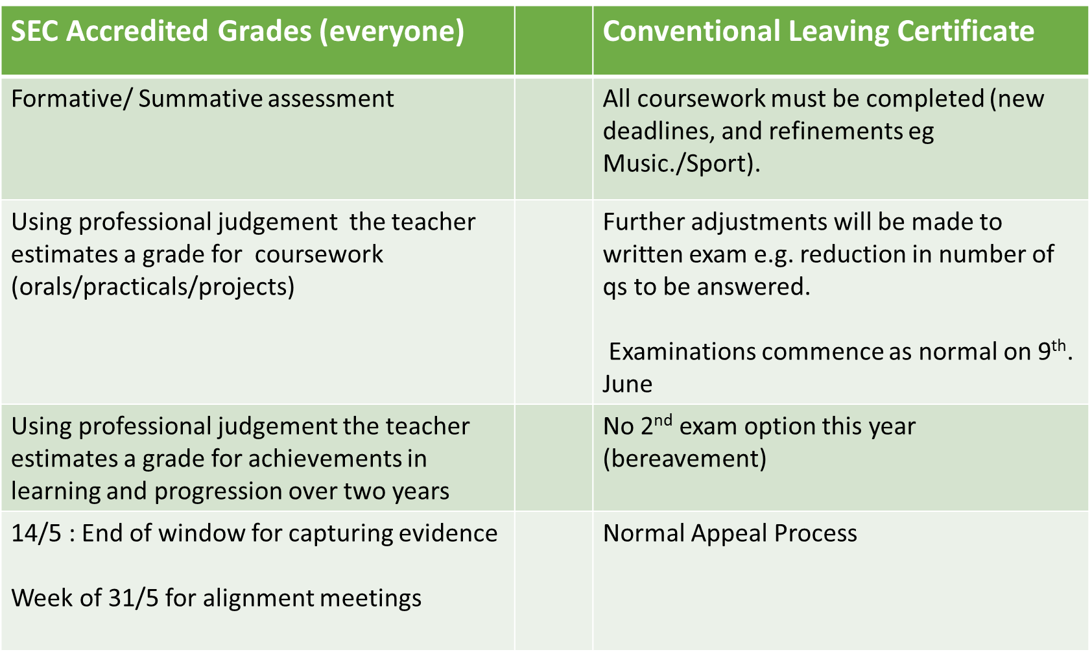
Options for LC/LCA students
- Students can choose to sit the examination
OR
- take an accredited grade
- OR
- they can choose both options.
- They can choose this on a subject-by-subject basis
- If they choose both options in a subject, they will receive the better of the two grades for that subject
- They will receive one set of results

Accredited Grade Process
1. The teacher’s estimation of student percentage marks – what a student was likely to achieve if they sat the LC (modified paper) in 2021.
2. School alignment of marks for a subject through a subject alignment group comprising teachers who are teaching the subject to Leaving Certificate students this year
3. Oversight of the alignment process by the school principal
4. Transmission of the marks for national standardisation.

What evidence can teachers use for accredited grades?
- Assignments, projects and practical work
- Performance in class assessments – questions, house or term exams
- Work during school closure should be used with caution
- Performance on any coursework component, even if this has not been fully completed
- End of topics tests, continuous assessment, aural and oral assessments
- Any other relevant information related to student performance

Coursework – what happens if certain aspects cannot take place?
- If not possible to hold the practical, the proportion of those marks is awarded elsewhere in the coursework e.g. PE performance assessment/Construction Studies and Engineering day practical’s
- Music: Group singing performance: discussions are ongoing on this matter
- Marks will be re-allocated within the coursework, not re-allocated to the exam
- Public health advice trumps all coursework

We strongly advice students to avail of both options

Student A
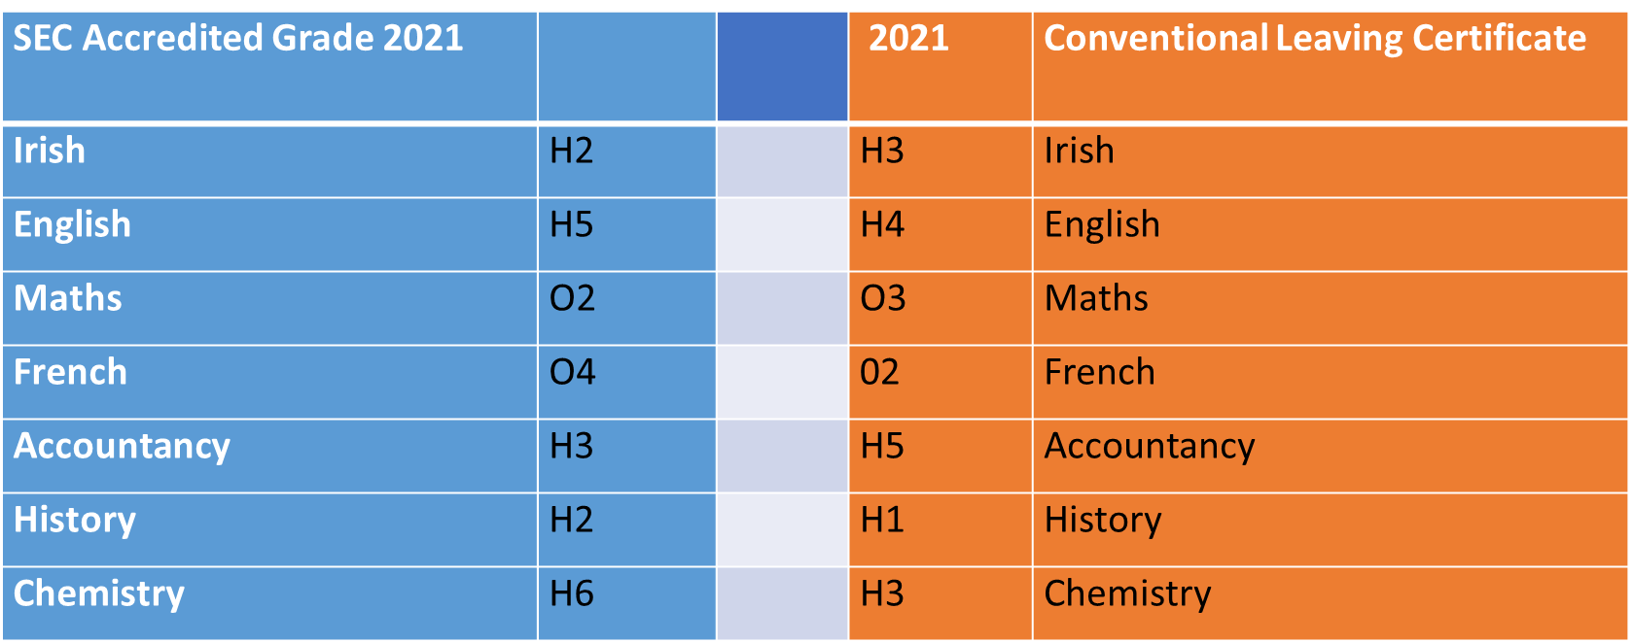

Student A
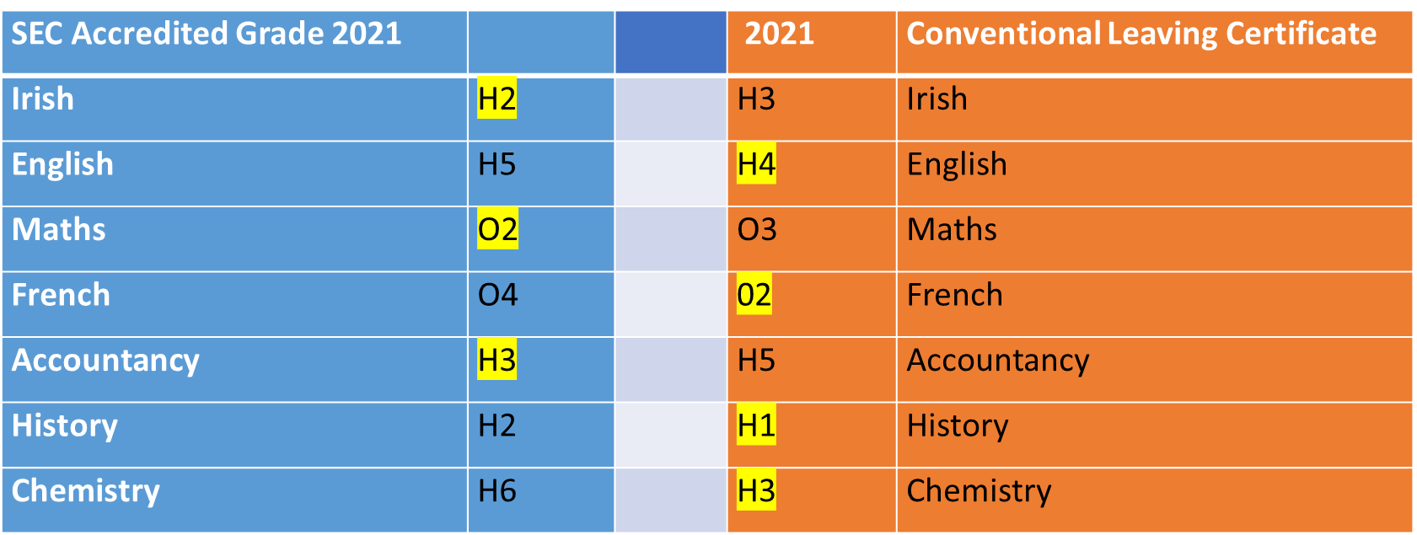

The better of the two grades will be on the final certificate.

Combined results for student A
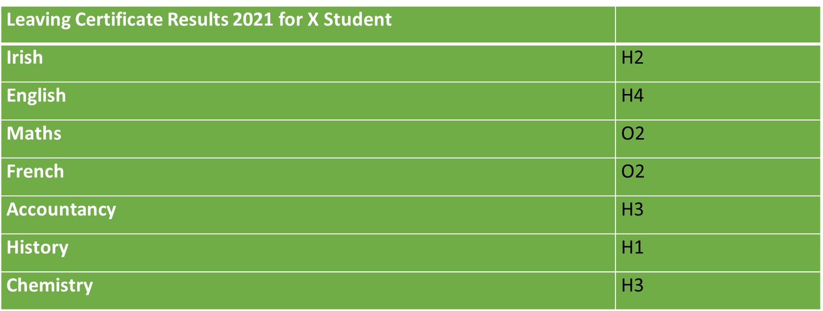

Orals/Coursework

- Guidelines coming from SEC
- Window of Assessment – 26 March to 15 April
- Will take place in the school outside of normal school tuition time
- Dates for coursework will be amended
- Teacher, or another teacher in the school (proficiency), or a teacher in another school, or a retired teacher (must all be suitably qualified)
- Record the oral on SEC device

Advice on testing between now and the summer

- No need for pre-exams – cannot be used in the accredited grades process
- Advice is to set three one hour exams over the coming three months – these are allowed to become part of the accredited grades process
- Teachers are preparing a schedule for student ( ready in the coming days) so there will not over testing in any given day

Appeals

I hope this letter will help you to understand the new process a little bit better. Please do not hesitate to contact any staff member or me should you require any further assistance.

Stay safe,

____________________
Patricia Lynam

