Remote teaching: Guidelines for Students
Context:
In March of 2020, all schools had to close due to the Coronavirus pandemic. The initial 2-week closure was extended schools did not reopen until September. In difficult conditions, students remained connected and engaged in schoolwork and teachers were flexible and creative in delivering their lessons. We are eager to learn from the experience and a protocol is now place, which will aid students and teachers in their engagement in the process.
Aim
The aims of this protocol are:
- To ensure continuity of teaching and learning.
- To maintain the connection with the school community
- To encourage students to take responsibility for their own progress and to have a sense of pride and purpose in their work.
- To support students and teachers in engaging with remote teaching and learning

Reflections from lockdown
During the lockdown in March teachers and students had to adapt quickly to the situation that was unfolding. As we are part of Cork Education and Training Board, our platform is Microsoft Office and we use MS Teams for scheduling of live classes and MS OneNote in order to set and receive homework. MS OneNote can also be used for class notes and sharing of materials between the teachers and the students. Other learnings from lockdown include:
A variety of methodologies are required:
Teachers and students reported that the online lessons were difficult for all involved and that a mixture of live classes, recordings and time to work on questions was the most welcome approach. Teachers will plan the weeks work for each class so they will have notice of scheduled live classes and independent learning. They may also be required to do some homework outside of their scheduled class times.
On line learning and teaching is challenging for students and teachers:
Technology and broadband quality is an issue for teachers and students. Some students will be using their smart phones and won’t have access to laptops. Contact your tutor or the principal to see if we can help with this issue. If you have an XBOX or PlayStation, these can become educational devices
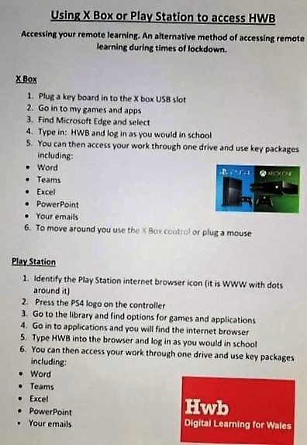
Maintaining School Routine is Important
The importance of ‘school routine’ for students and the need for breaks as they found it difficult to be on screens all day was clear from our student survey. They should be ready to start work each day at 9.05am and should follow their timetable, taking breaks at the appropriate times. Their teachers will plan out their weeks work and will allocate time for independent learning & live classes. Students should work according to their timetable and should work on their subjects during their allocated class time for that subject. Teachers will endeavour to give adequate notice both in scheduling classes and setting deadlines for homework/assessment.
Notifications of Work
Where possible teachers will give notifications of work /classes during school hours and with adequate notice. This may not always be possible as teachers and students may need to send a communication outside of school hours due to their own circumstances. Students and teachers are not expected to check for notifications outside of school hours. Any communication sent outside of school hours should be dealt with the next working day.
Attending Live Classes Online
Many students are sharing devices with siblings and it may not be feasible for them to attend all scheduled classes. They should however inform their teachers of this and should do work associated with that subject during the class time. Students can inform teachers via email or by sending them a message in MS Teams. Where students miss classes they should be aware that they are missing out on important teaching and learning opportunities and the work covered may not be revisited when students return to school.
Vsware will record both positive & negative comments – parents have access to this
Student Support
Where students require support during any period of lockdown, as they would do in school, they should firstly communicate the issue to their subject teacher. Use MS Teams or email to make contact. Each student has a class tutor. The school secretary is available on info.office@mcegan.ie or principal trish.lynam@mcegan.ie for any issues with logging on or passwords. It is important that students who are struggling or feel isolated reach out. Our guidance counsellor, maryb.manning@mcegan.ie or our HSCL teacher kevin.clarke@mcegan.ie or our SCP coordinator Colette.dineen@mcegan.ie will be available to offer support and advice.
To recap:
- Get into a routine
- Follow your school timetable (including breaks)
- Set up a desk and chair in a place where you can work
- Ensure you know what classes you have on MS Teams each day
- Plan out the independent learning and homework set by your teachers
